Chapter 4
How to Exercise

I’m not into working out. My philosophy: No pain, no pain. - Carol Leifer

Behavior Analysis: Hedonistic Stoicism and Running

Until I was almost 40, I thought the case for exercise was hopeless. Not because exercise might not benefit us, but because we wouldn't find enough reinforcers in exercising to keep us hanging in. I thought the way to hell was paved with closets full of unused Adidas running shoes. But since then, I've found out otherwise. Physical exercise is peppered with little unexpected reinforcers. In fact, physical exercise is a good example of what I call hedonistic stoicism. So's my no-processed-sugar diet. The diet looks barren because you must deprive yourself of all those processed-sugar treats the food industry has spent millions designing so that you couldn't resist them and so they could make billions off of you, in spite of the fact that they were killing you prematurely. And it's stoic to give up all those sizable, probable reinforcers that white-powdered death brings to your taste buds. But it's very hedonistic to drown your sorrows in a fruit smoothie. You can awe people with your disciplined stoicism, as long as they don't know you may be an even bigger hedonist than they are. Just 'cause it's nutritious don't mean it has to taste bad.

Well, the same sort of hedonistic stoicism applies to exercise. And more and more Americans are getting hooked on it, with their running and their racquetball. In fact, psychiatrist William Glasser calls it the positive addiction. He claims that if you exercise 40 minutes a day for six months, you'll become addicted to it, you'll find it intrinsically reinforcing to do and aversive not to do. From then on, you'll keep on exercising without any added performance-management program. And there may be something to that, though I'm afraid he's a little too optimistic. It will get easier to keep exercising, but you may need a little performance-management to maintain the level of exercise with which you're most happy.

I ran a 26.2-mile marathon in Detroit a few years ago with 4,000 other people. And I think there had to be a lot of hedonism involved for that many people to do enough training to be able to run so far. Four-thousand crazy Michiganders can't be that wrong. And every year, there are marathons all around the country, several times the size of that one. Something's happenin' here.

So let me suggest some of the things I think are happening, some of the reinforcers that make running and other forms of endurance exercising so great.

First of all, stressful exercise produces a physiological reaction called the activation syndrome- increased heart rate, increased breathing rate, etc.
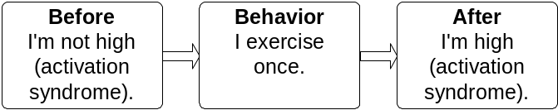

Emotional reactions also produce essentially the same activation syndrome.

For instance, when you watch an exciting movie, your heart rate and breathing rate may increase slightly. The physiological reaction seems to be an unlearned, basic biological reinforcer. And this reinforcer may account for why we do many of the things we do, unhealthy as well as healthy things, such as sky diving, shop lifting, arguing with other members of our family, taking certain stimulants, going to see Jaws, and exercising. You see gerbils in activity wheels, monkeys in their trapezes and horses in their fields, all producing that reinforcing activation syndrome by exercising. It looks like many of us animals have evolved so that exercise produces this natural physiological reinforcer. And the reason we've all evolved that way may be because exercise produces various long-range health benefits that enhance our chances of survival.

Now many people talk about this runner’s high they experience while they're running. But I must admit that it's fairly rare for me. Instead, here is what I really get off on -the post-run high. But "high" isn't exactly right. It's a tremendous, relaxed, laid-back feeling. However, I only get it when I've run to near exhaustion, when I've pushed my limits. And after I've really pushed my limits, say a 20-mile run, I'm so trashed that all I can do is eat my rolled oats, sleep for a couple of hours, and watch a golf match on the tube. But I love it. It really feels great. It's one of my favorite ways to waste my time. And like the sensory and spiritual reinforcers of sex, it's hard to describe to those who haven't experienced it.

Another big reinforcer for exercise is progress or signs of improvement, like being able to run faster, or farther, or for more consecutive days without missing a day. Progress is much more important than we often think.

Here's an interesting feature of progress as a reinforcer. I'll train really hard all summer, with the hope of getting my 10K pace down from 7:05 to 7:00 per mile, a mere 5 seconds. But I wouldn't pay 50 cents for a pill that would let me get down to 6:00 per mile. You've got to earn that progress before it functions as a reinforcer.

There are also plenty of social reinforcers. Have you ever known a closet runner? I haven't. All runners tend to casually wear their New Balance 7305 much like Boy Scouts wear their merit badges. We make sure the world knows about our accomplishments, no matter how humble. And we get plenty of social approval from both non-runners and fellow runners.

That's one nice thing I've noticed about the running community. Its members tend to be very supportive of each other. A runner who finishes a 10K race in 50 minutes may be just as thrilled as the runner who finishes in 35 minutes. And they both congratulate each other with equal enthusiasm.


Now that doesn't mean there can't be a little friendly competition as well, but not between the 50-minute runner and the 35-minute runner. However, I do see runners set their goals on beating a fellow runner who may tend to finish a minute or so before them. But it’s no fun to beat that person if he were ill or off his training and not able to do their best. Or maybe I should say it's not as much fun.

Running local races is generally a big source of motivation, not only because you get a chance to set a personal record, but also because you get to interact with your fellow runners and swap times at the end of the race…many opportunities for social reinforcers. Also after a few races, you begin to notice many of the same faces at each race; and running friendships gradually form. Now many of these friendships never extend beyond running, but they're really great in that context.

General Rule: The Greatest Thing They Ever Did

I met a man who advocated this rule:
If a person says something is one of the greatest things they ever did (one of the biggest reinforcers they ever had), try it at least six times before giving up on it.

He said someone told him tent-camping in the snow was one of the world's greatest reinforcers. He then said he'd tried snow camping once without much success and had 5 more times to go.

Well, completing a 26-mile marathon is one of the greatest things thousands of people have ever done. Imagine running 26 miles; that's as far as from your house to way the heck outside of town. Amazing, isn't it? But you can do it, and within one year from now.
Behavior Inertia Rule: It’s harder to start most behaviors than to keep them going.

The hardest step is the first step. The hardest part about running is putting on those Adidases, opening up the front door, and walking out to the street. Once you're out there, it's easy to keep on moving. And once you're moving, it's easy to go for as far or as long as you planned. I've been running for over 20 years, and rarely had any trouble going the distance, once I'd started, and occasionally, going even further, a rare positive benefit of behavioral inertia. But I've often had trouble putting on the shoes and opening the front door. So, if you feel too tired to run, and too busy to run far enough, at least put on your shoes, and go for a walk around the block. Five'll get you ten that, once you're on the street, you'll gradually end up running, and running the distance; but, even if you don't, at least you did a little something.

Note that I'm talking about a single episode of a hard behavior, like running or writing or reading or house cleaning. In other words, it's harder to get yourself to start cleaning the house, but it's not so hard to keep at it once you're half way there. Same with studying. I know you might be distracted once you start studying, but it's still harder to start a single study session than it is to hang in for a full hour or two. But it's easier to start a long-range project than it is to keep it going. For example, many people have started writing books, but not many people have finished them. And also, many people have started working on their Ph.D. Degrees, but only 60% have hung in long enough to actually finish them.

How to Run a Marathon a Year from Today

Start walking, every day, for as long as you're comfortable, maybe up to an hour.

After a few days, start an occasional slow jog. Jog as slowly as you can, almost as slowly as when you were walking.

Jog only as far as you're comfortable, a few yards, a block, a mile.

Walk awhile, and then try another jog.

Every day, see if you can increase the distance of your slow jog, but keep it real slow. Eventually you will be able to jog as far as you had been walking.

After you can slow jog the whole distance, you can start to pick up the speed, very gradually.
General Rule: Never jog so fast you can’t carry on a comfortable conversation with a jogging companion.
General Rule: Beginning joggers should never jog so fast or far that they feel trashed afterwards or stiff the next day.

At the same time start increasing your miles per week, by 5 to 10% a week. Running the same distance every day.

Keep increasing your miles consistently across days until you hit 6 miles/day. Then add your increased miles to three interspersed days, like Wednesday, Friday, and Sunday.

Keep adding miles on those three days until you hit 12 miles/Wed., Fri., Sun. Then add your increased miles to Sunday, until you hit 20 miles on Sunday.

Now your running week looks like this:

Monday. 6-mile short recovery run

Tuesday. 6-mile short recovery run

Wednesday. 12-mile medium run

Thursday. 6-mile short recovery run

Friday. 12-mile medium run

Saturday. 6-mile short recovery run

Sunday. 20-mile long run

Variations and details:

Monday. Many experts recommend not running at all on Monday, to allow for better recovery from Sunday's long run, but I prefer to keep a daily regimen.

Sunday. Probably only do one 20 miler per month. Drop it down to between 14 and 18 on the other weeks.

Tuesday and Thursday. Two or three of those miles on Tuesday and Thursday should be speed work, more or less as fast as you can, for a block, or a lap 5 around the track, or a mile, or whatever. Mix it up.

Once you hit the 68-mile weekly goal, you might want to alternate among low, medium, and high-mileage weeks, just like you alternate among low, medium, and high-mileage days.

If you're overweight, you should also go on a calorie-counting diet. I have found that I have to watch my calories, even when running 68 miles a week, though the exercise does help me control my weight.

Go to the book store and buy one of the many good books on running and training for a marathon.

Subscribe to one of the monthly running magazines. It’ll pump you up.

Run 5K and 10K races. They’re fun. You meet other runners. They give you sub-goals. And they also give you some speed work.
- Exceptions to earlier rules, following a good speed workout, or a good race, or a good, long run, you should feel pleasantly trashed. And some writers even say, that if you can walk up the stairs forward the day after a marathon, you didn’t give it your all. (I must confess, I’ve never had to walk up the stairs backward; but I do know what they are talking about.)
Isn’t that amazing? You could actually do it, you could start from a sitting position on the couch and end up running 68 miles a week and on one fine Sunday, a 26 mile marathon! What may be more amazing is that you might actually want to.

More Reasonable Options

Not up for the big one, the 26-miler. No problema. Aim for a 10K race/fun-run (6.2 miles), or a 5K, or a brisk walk around the block. It’s all cool.

You can still use the above training plan, just scale it down to size.

General Rule: Avoid the Returning Runner Error

You were an all-state, all-star, cross-country runner in high school. Six miles at six minutes per, was like a stroll around the block for you. But for the last three years, the only exercise you've gotten is cracking books to study for exams. You're inspired by the marathon-training plan, and you're ready to hit the streets. But you don't need to pussy foot your way back up to a serious training schedule. Wrong. You're going to start out at 6 for 6. Wrong.

Don't do it. I've seen too many ex- jocks burn themselves out their first day on comeback road and hang up their Adidases once again. Start slow, real slow, maybe not as slow as I'm recommending, but slow, and short. You’ll get there, maybe fairly quickly, but gradually. Please don't be another one of my burnout statistics.

Aerobic Options

I'm into running, and a lot of other people are too, and I recommend that you give it a good try; but you may find it's not for you. For example, I know a woman who more than met Glazer's criterion of 40 minutes/day for six months. But it didn't ring her bell; the positive addiction didn't kick. So she went back to aerobics, which she loves. However, you can use the same performance-management approach to maintaining lifelong walking, swimming, stair mastering, TV aerobics -whatever you want.

General Rule: Get an Exercise Buddy

Sonia Acousta did her MA thesis on running buddies. She found that college students who had running partners exercised more reliably than those who didn't.

Of course, having someone to chat with may make running more fun; but I don't think that's the main factor. I think it's that you don't want to cop out on your commitment to your buddy. You said you'd be down to the gym to work out with her, and you're not. What kind of buddy is that? It's guilt that gets you to hang in on those days when you'd otherwise have copped out.
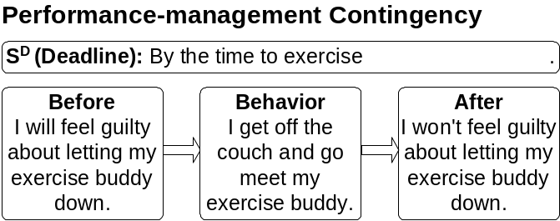

The buddy system is so crucial that very few runners manage to do those long Sunday runs or the intensive speed work without some buddies. In fact, commitment to an exercise buddy can help with any form of exercise, not just running.

General Rule: Double Your Pleasure

You can make exercise more enjoyable by combining it with other activities you like to do. Try listening to audio books while you run, reading a good book while you’re on the exercise bike, or jamming to your favorite music while you’re pumping iron.

Stay Loose and Toned

Now here's the best part, and the part most aerobics exercisers miss, stretching. It's the best part, because after a good workout, nothing relaxes you more than a few minutes of stretching (at least nothing you can do by yourself?). Try 5 to 20 minutes. Big-time, long-range benefits too, including injury prevention. But do your stretching after you've done your aerobics, after your muscles are warm and lose; otherwise, you risk injuring yourself, in your efforts to prevent injuries (this is contrary to what many people have learned, but this is what most running coaches recommend).

The other part is toning, especially your upper body. The big ones here are pushups and sit-ups or curls and chin-ups; they strengthen those stomach muscles. At least half of you are going to end up with a bad back, which can often be dealt with and maybe prevented with those tummy strengtheners.

The pushups and chin-ups also strengthen your biceps, etc. You might also want to go to your local sports store and pick up some rubber-band resistance items to further strengthen your upper body.

Now, I'll confess, like everyone else, I also have a much harder time keeping my stretching and toning act together than my aerobics act; but I try.

Behavior Analysis: Peak Hedonistic Stoicism

Now for near peak hedonism, try this: Do a half-hour, an hour, two hours of good aerobic exercise, take a nice hot shower, put some really mellow music on the music maker, grab your bowl of Uncle Dickie's rolled oats with yogurt, and relax into 10, 20, 30 minutes of stretching and toning, while you intermittently nibble on those oats. After you do that, you'll swear you're going to do it every day for the rest of your life, but we know better, don't we; you'll need a self-management program, to get yourself to hang in, even a small percentage of the time, in spite of how great it feels, when you do. Weird, isn't it?
Exercise is the yuppie version of bulimia. – Barbara Ehrenreich (b. 1941)
Your Friend, Mr. Oxygen
I’m getting an increasing respect for oxygen. It seems to be the vital force supporting much of what we hold dear. Things seem to work better when there is plenty of it around. For instance, if you have a compost pile to convert your lawn clippings and kitchen scraps into compost for your garden, then you want to get plenty of oxygen into it, via aeration, to encourage the growth of aerobic bacteria that need oxygen to live. These aerobic bacteria eat the plant material and excrete the compost material much more rapidly and with less odor than the anaerobic bacteria that can live without oxygen.
And if you have a garden, then you also want to get plenty of oxygen into it via aeration, again to encourage the aerobic bacteria that are also much better than the anaerobic bacteria at producing excrement that contains more usable nutrients to support the growth of your garden’s plants.
Furthermore, anaerobic bacteria thrive in your colon on our typical high-fat diet where they produce large amounts of carcinogens, possibly accounting for the high correlation between dietary fat and colon cancer. Of course, anaerobic bacteria may also do a few good things for us too.
But enough about aerobic and anaerobic bacteria. You are largely an aerobic organism; your cells need oxygen in order to survive and thrive. And endurance exercise (aerobic exercise) such as long, slow runs, improves your body’s ability to get that vital oxygen to its cells. Here’s how: Aerobic exercise improves your lungs’ capacity to take in oxygen; it improves your body’s ability to load up your blood with that oxygen; it improves your artery and blood vessel’s capacity to transmit that blood; it improves your heart’s ability to circulate that blood through those arteries and vessels; and it improves your cells’ abilities to take that precious oxygen from your blood.
Nine Benefits of Running and Other Aerobic Exercise
Here are some benefits resulting from exercise and also from this improved aerobic capacity:
☺ Healthier, less brittle bones
☺ A higher metabolism rate that burns off more calories for several hours after you’ve exercised as well as while you’re exercising.
☺ A less inappropriately large appetite.
☺ Better weight control.
☺ Better health in old age.
☺ More strength, endurance, and coordination.
☺ Less heart disease because exercise reduces the effects of atherosclerosis, the clogging of the coronary arteries that carry oxygen-filled blood to the heart muscle. Exercise reduces the effects of clogged arteries by opening up new pathways for the blood to get to the heart. For example, the frequency of death due to heart disease is 5 times as great for sedentary men as for physically active men.
☺ A reduction in hypertension (high blood pressure) because exercise increases the growth of new capillary arteries, allowing for more blood flow with less pressure. For example, the Bantu of South Africa do much heavy work and have practically no hypertension. And experimental evidence shows that men who have hypertension can greatly reduce their blood pressure by physical exercise.
☺ Reduction of high blood-fat levels in diabetics, because exercise causes the diabetic to burn up blood fat for the needed energy. And exercise combined with a low fat, low sugar diet can often eliminate diabetes.
Our growing softness, our increasing lack of physical fitness, is a menace to our security. – John F. Kennedy (1917-63)
The safest road to hell is the gradual one – the gentle slope, soft underfoot, without sudden turnings, without milestones, without signposts. – C. S. Lewis (1898-1963)
Studies Show It Is Possible to Keep the Pounds Off Low-Fat Eating and Physical Activity Is the Key, Comments NAASO Expert
Despite popular opinion to the contrary, maintaining weight loss is not impossible, according to two new studies presented at the 8th International Congress on Obesity in Paris, France. The studies of people who have successfully kept off the pounds found that low-fat eating and increased physical activity were keys to success.
"People are always asking whether we have anything that works," said Dr. Hill. " These studies suggest that the answer may be low-fat eating and increased physical activity."
In one study, low-fat eating and physical activity were keys to the success of more than 2,000 individuals in the National Weight Control Registry who successfully maintained a 30 kg (66 lbs) weight loss for at least one year. Those individuals also reported a much-improved quality of life. In another study, physical activity arrested the process of weight regain in previously obese inactive women. When the physical activity program was discontinued the women regained weight.
Research Confirms Essential Role of Daily Physical Activity in Maintaining Weight Loss
Studies show Americans need to increase physical activity to counter the obesity epidemic and how physical activity can be integrated into a busy lifestyle by accumulating several short periods each day.
CHARLESTON, S.C. -November 15, 1999 - Three landmark studies presented today at the annual meeting of the North American Association for the Study of Obesity (NAASO) address the role of exercise in losing weight and improving health. One of the studies also suggests that adults can exercise in several short periods during the day to get the activity necessary to maintain weight loss.
A study presented by Rena Wing, Ph.D., Brown University School of Medicine, Providence, R.I. and University of Pittsburgh, Pittsburgh, Pa. suggested that higher levels of activity may be needed to promote long-term weight loss than had previously been thought. Former recommendations of burning up to 1,000 kcal/week may not be sufficient to maintain weight loss successfully. Data from the National Weight Control Registry -a voluntary registry of 2,500 individuals who have lost on average 60 pounds and kept it off for more than one year showed that expending an average of 2,800 kcal/week (equal to about 60 minutes of moderate physical activity per day) was associated with long-term weight loss.
Research performed by John Jakicic, Ph.D., and colleagues from Brown University School of Medicine in Providence, R.I. and University of Pittsburgh, Pittsburgh, Pa, revealed that short bouts of exercise throughout the day is as effective in maintaining weight loss as longer bouts of exercise performed once a day in overweight women.
"This study has important practical implications because it may be easier for many people to increase their activity for short intervals during the day than to set aside a full hour for exercise", said James 0. Hill, Ph.D., professor of pediatrics and medicine at the University of Colorado Health Sciences Center in Denver, Colo. and an official of NAASO.
A third study presented today by Steven Blair, Ph.D., of The Cooper Institute, Dallas, Texas, indicated that exercise has benefits independent of weight loss itself. Exercise improves cardiovascular fitness, which is directly related to decreased risk of death from heart disease. In fact, the study showed that obese persons who were physically fit had a lower mortality rate than lean persons who were sedentary.
"Obesity has reached epidemic proportions in the United States," said Dr. Hill, "When 22 percent of the U.S. population is affected with a chronic condition that kills nearly 300,000 people each year, there is a major problem--one for which we must find remedies. If Americans could find a way to incorporate more physical activity into their daily lives, we would be one step closer to addressing this problem."
The North American Association for the Study of Obesity (NAASO) is a leading scientific society dedicated to obesity. NAASO is committed to encouraging research on the causes and treatment of obesity, and to keeping the scientific community and public informed of new advances, as it becomes more widely recognized as a disease and public health threat.
Http://www.naaso.org/newsflash/exercise.htm

How to Keep up a Lifelong Exercise Program

At the time of this writing, I've been running more or less daily for over 25 years. And it always requires some sort of performance-management contract to keep me from joining the large numbers of used-to-runs. It's so easy to say I'm too busy today; I'll run tomorrow, only to discover that a year later you've gradually degenerated into a couch potato. By now, you shouldn't be overwhelmed with the difficulty of imagining what my contingencies look like.
I’ve run so many miles on comeback road, sometimes it seems like the only road there is. – Uncle Dickie
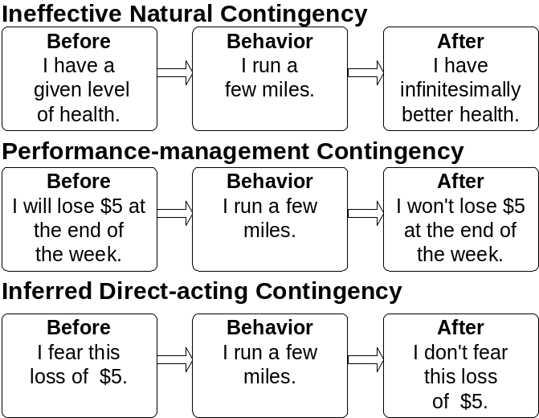

I love the running life style. I love standing in a hot shower, experiencing the endorphin rush after a 6 miler. But without performance contracting too many other contingencies would get control over my behavior, like work contingencies, watching-TV contingencies, and even sitting on my duff contingencies. By the way, I have a daily running deadline. But, nowadays, I don't lose the $5 until the end of the week when I total up my penalties for the week and add them to my computerized expense ledger (I actually pay out the cash only twice a year).
The only athletic sport I ever mastered was backgammon. – Douglas Jerrold (1803-57)

Recycle City

Of course, your program will fall apart many times throughout your life; no big deal, just patch it back together and keep right on truckin'. After you've been in the self-management biz for a while, you don't panic every time you fall off the wagon. You feel like a despicable, lowlife bum; but you don't panic. You don't panic, because you've picked yourself up out of the gutter of physical, moral, and spiritual degeneracy before, many times; and you know you'll pick yourself up again. I live half my life on comeback road. Yes, boys and girls, just keep on truckin' with Uncle Dickie up that comeback road. You can do it.

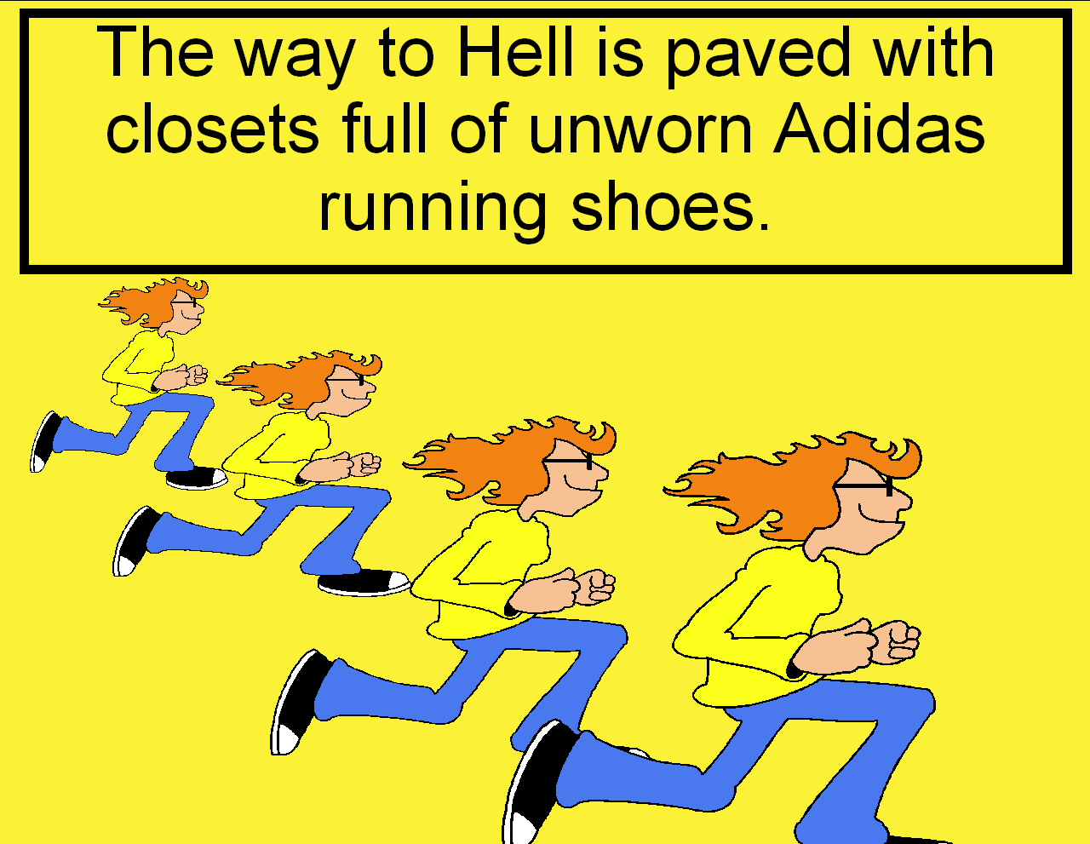
Case Study: Exercise
Lisa Haroff, MA Student, 1998-99

To begin this project, I had to ask myself, “What's an evasive goal I'd really like to achieve that would contribute to my long-term health and happiness?" The answer is, “to have exercise become part of my daily routine." I believe exercise to be a critical component to over-all health and fitness; but, for the past 8 years of my life, I have been unable to maintain an exercise program for more than a month at a time. The mind is willing but the flesh is weak! I estimate my retrospective baseline level of exercising to be something like 1-2 hours of activity (involving an increased heart rate) per week. How come? And what am I doing about it now?

Analysis

My case is a classic example of poor control by an outcome that is too small, but of considerable cumulative significance.
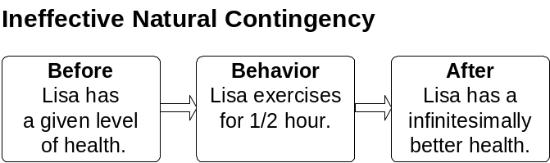

Performance Objectives

I decided to start small, and gradually increase my performance requirements. Since my baseline rate was approximately 1 hour of exercise per week, I set my initial goal at 2 hours of exercise per week. An increase from one to two hours is a significant increase, but not more than I can reasonably expect from myself. And I would accomplish my 2-hour goal by exercising for four ½-hour sessions per week.

Design

Being a poor college student, money is something I definitely try to avoid losing unnecessarily. So I thought a performance-management contingency based on the avoidance of the loss of money would provide sufficient motivation for me to accomplish my goal.
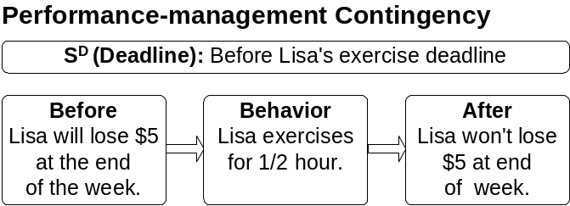

Implementation

In order to begin my intervention, I had to select a performance manager. I chose my roommate because she's handy and also because she's what I call a “fitness guru." She is a good source of information and advice, but not only that, she loans me things like exercise tapes and weights. Her advice, for example, the suggestion to vary the type of exercise I do, has been truly helpful. I began the intervention 2 weeks and 2 days ago, on Tuesday, July 28, 1998. Let's take a look at how it's going.

Evaluation

Well, so far, so good. During the first week, I put in my required 2 hours (actually a little more than two). I rode my mountain bike, did aerobics, went for a long walk, and did toning/strength building. The second week wasn't as good. I only put in 1 and ½ hours. Therefore I lost $5.00. It doesn't seem like a lot of money, but it was irksome! (I thought of all kinds of excuses!) But perhaps the benefit is that, during this second week, I started to see some flaws in my intervention… So far, I've “lost" $65, but I've only paid $40.
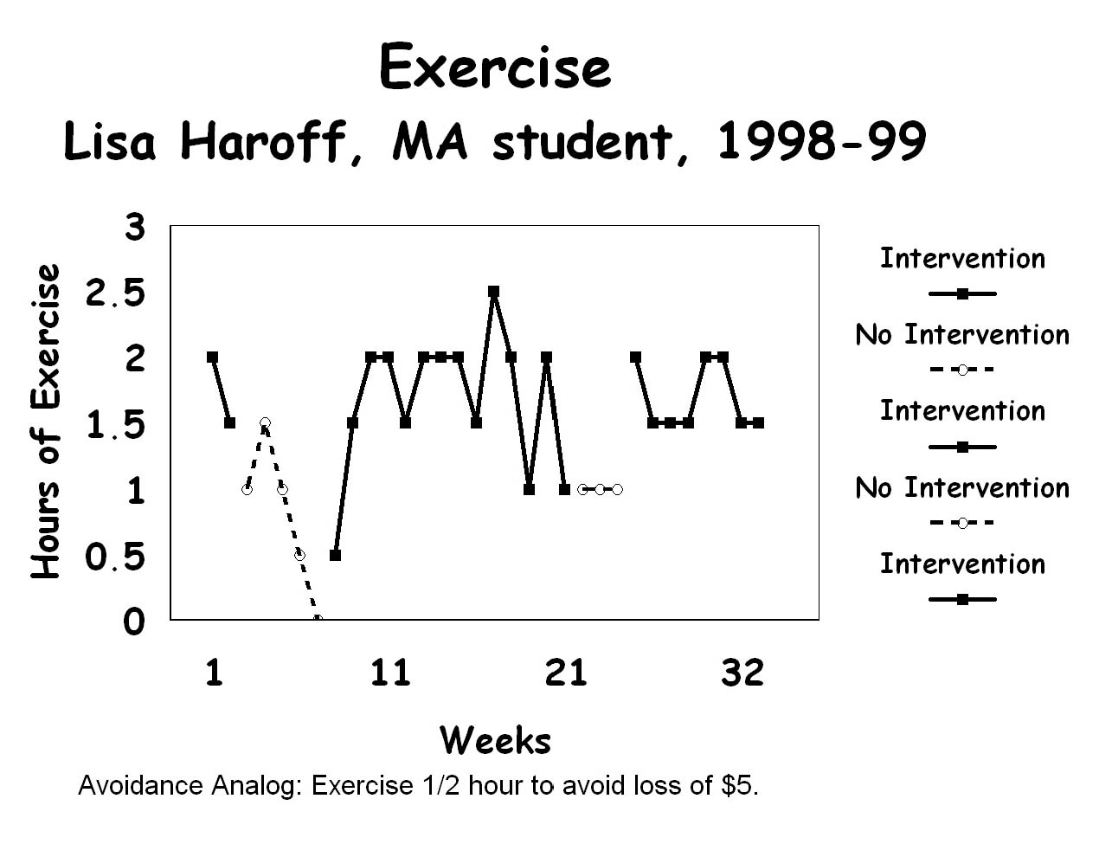

Recycling

I'm just now in the process of making the following revisions:

Asking my roommate to question me daily about the status of my goal for the week. I find that if she doesn't ask, I only tell her when I did exercise. I avoid having to tell her I didn't. Reporting to her every day might increase my motivation for exercising- I would avoid having to tell her I didn't exercise by then actually exercising! I remain open to the possibility that I may need a PM contingency to maintain her performance (asking).
- Pinning four $5.00 bills to the corkboard on our refrigerator instead of one $20.00 bill so I don't have to make change when I “mess up." (Last week it took me 3 days to cough up the $5.00, and then I never put the remaining $15.00 back on the board.) I must say , it does help to have that money staring me in the face every day when I go to get my orange juice though!

Requiring that I exercise 3 times during the week, and once on the weekend, for example: Tuesday, Wednesday, Thursday, and Saturday. I want to have some built-in flexibility to allow for schedule changes etc., but I don't want to find myself having to get in 2 hours of exercise on Friday, Saturday, Sunday, and Monday (since my week runs from Tuesday-Monday).

Asking a fellow class member to be my performance manager if my roommate can't bring herself to be tough enough!


Case Study: The Case of the $500 Dust Catcher

Based on a report by Stephen Albrecht (MA student, 1996)

Stephen plunked down 500 big ones for a Nordic Track ski machine. But, like most owners of exercise equipment, he wasn't using it. So he put his CD player where his heart was. He greatly enjoyed listening to his CD player during his daily commutes from Grand Rapids to the behavioral center of the universe, WMU in Kalamazoo.

So Stephen decided to really go for it. He contracted with his younger brother: If he didn't exercise at least 5 times during the week by 11:00 P.M. on Sunday's he would give little bro the detachable face (control panel) for the next six days-avoidance of the loss of a very powerful reinforcer for Stephen.
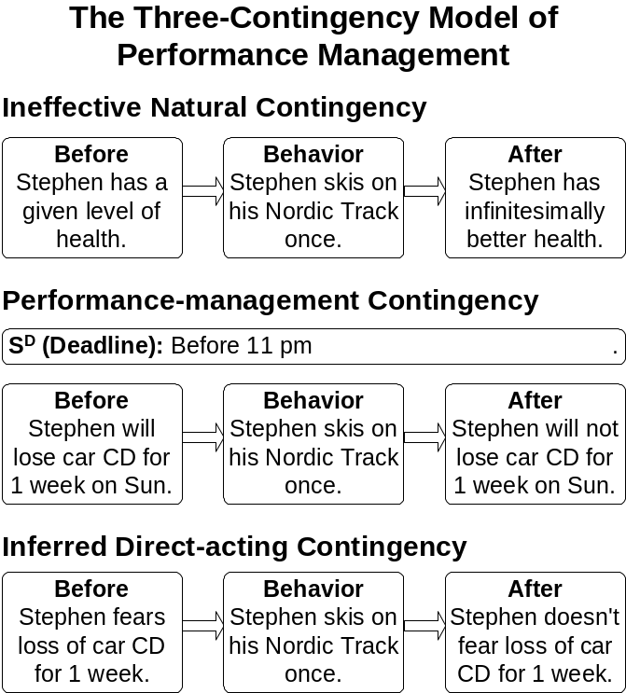
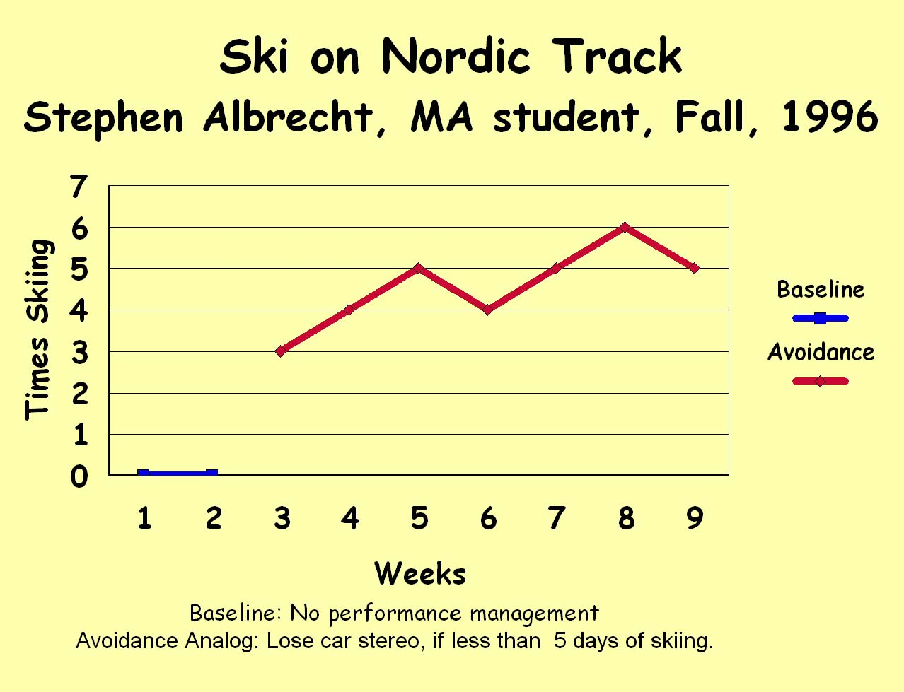

Case Study: How to Exercise and Exploit Your Ex-boyfriend
Lisa Fazzini, MA Student, 1999

Analysis

I took a look at the natural contingencies for my behavior of working out. They were definitely ineffective contingencies (especially because I hadn't done any type of exercise since my undergrad procrastination project).

Specification of Objectives

I wanted to work out 5 days a week for 1 hour each day. For the first week of my intervention I had stated that I had to workout Monday through Friday.

Design the Intervention

I had done this before and I set up the same contingency. Then it had seemed to work, until my performance manager stopped asking me how I was doing. Then the contingency fell to pieces and so did my exercise. This time my performance manager was my ex-boyfriend; and he got the fines. I would avoid losing $5 every time I worked out.

Implement the Intervention

I took baseline data for one week and then implemented this intervention on July 6, 1998. This performance-management intervention has been ongoing for 6 weeks now. I must say that it is working quite well.

Evaluate the Intervention

The first week I was supposed to work out Monday through Friday and I ended up only working out three out of the five days that week. I decided to change the rules a little bit to give me some flexibility and therefore I just had to work out 5 out of the 7 days of the week. This seemed to work pretty well, as you can see for the first two phases of the following graph.
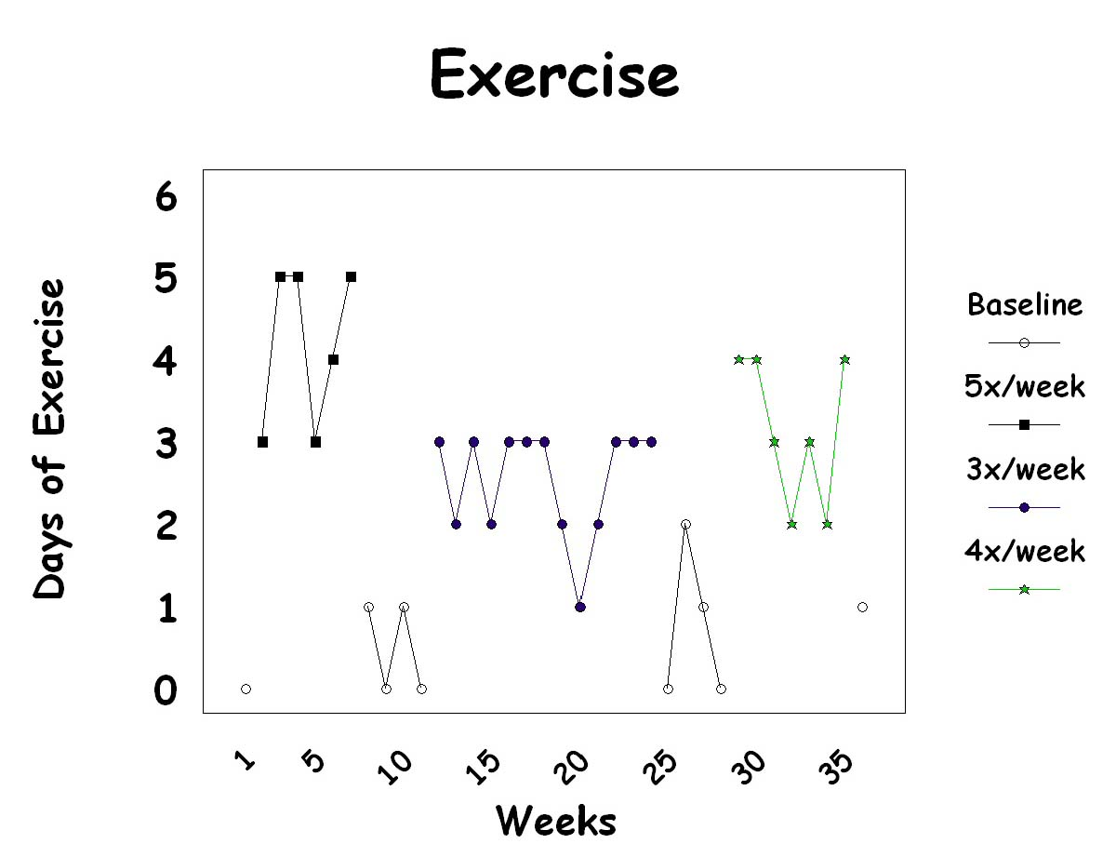

I think this intervention also worked especially well because I had to pay my ex-boyfriend $5 each time I didn't work out and that was extremely aversive because he was probably using that money to take out his new girlfriend. This definitely helped me to keep up with working out.

Recycle

I haven't got a perfect record yet, but I am working on it. I don't think there is anything else I need to change just yet; I think this contingency is helping me get some nice results. I would like to continue to keep this performance-management contingency going for as long as I can. When this particular contingency stops motivating me to work out, I will recycle. For now I am happy, and very healthy!

Follow-up

I started this self-management project this summer. I was working out 5 days a week. There are three different intervention phases because I changed the goal of number of days that I needed to work out each semester. The second intervention phase was 3 days per week and the third (and current phase) is four days per week. These data are also on the preceding graph.

By the way, notice the return to baseline, between each new intervention. My decrease in exercise without the performance-management contingencies clearly shows the need for continued performance-management contingencies.

Follow-Up: Voice from the past

I have moved to kick boxing 3 times a week and going to the gym for cardio and weights 3 times a week. I love it!! Kick boxing is great, we have this very militant ex-boxer that teaches the class. He literally kicks our butts when we miss, so it is great.

April Brown, MA, 1997

Performance Management

Meijer, Inc.



Hedonistic stoicism, you’ve got it – another oxymoron. Hedonism – pursuit of or devotion to pleasure, especially to the pleasures of the senses. Stoicism – indifference to pleasure or pain; impassiveness. (Microsoft Bookshelf 99). So I coined the expression, hedonistic stoicism – performing an act that appears to produce no reinforcers (pleasures), an act that appears to produce nothing but aversive conditions (pain), when really you’re up to your eyeballs in hidden reinforcers (pleasures).
From Glasser, W. (1976). Positive Addiction. New York: Harper Perennial.

